**Perforce Assignment**

**Developer**: Pavan Thute

**Assignment**:

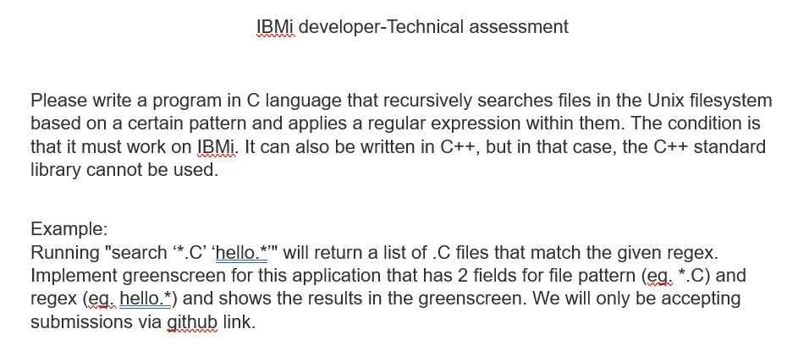

**Solution**:

Created programs in AS400 system as below:

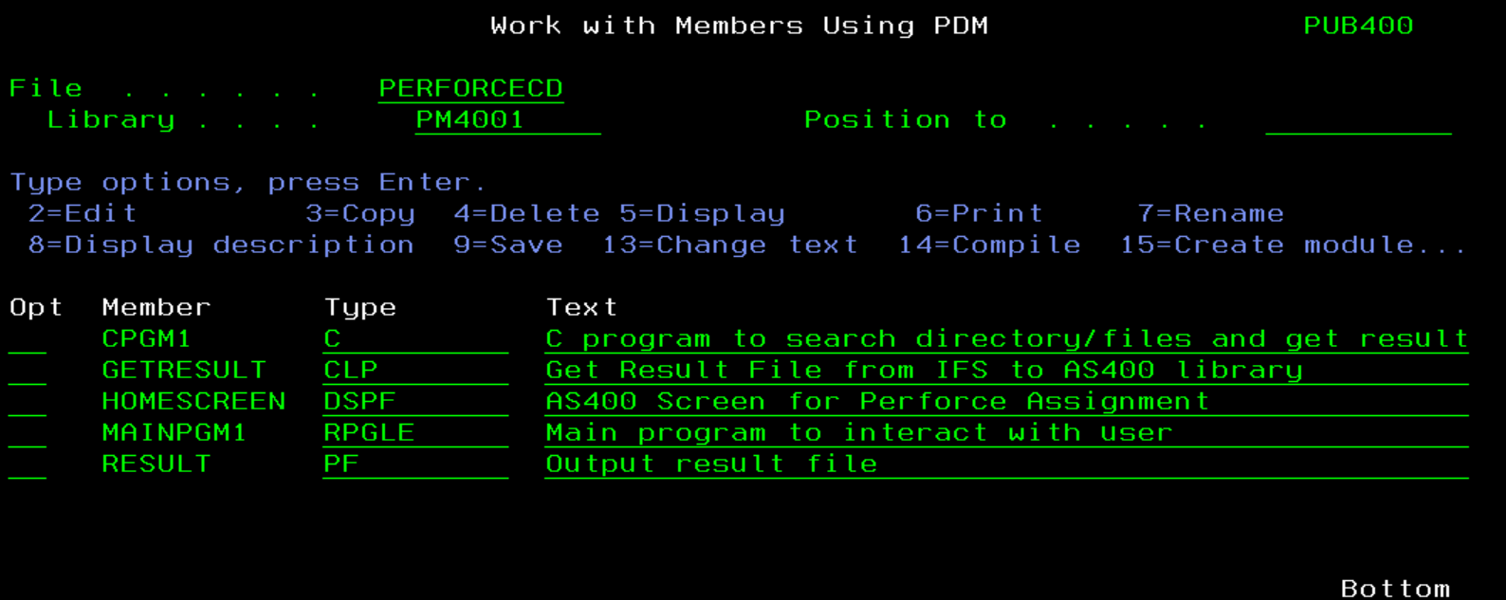

**Execution steps:**

Call program MainPgm1 and enter required filter data as shown below:

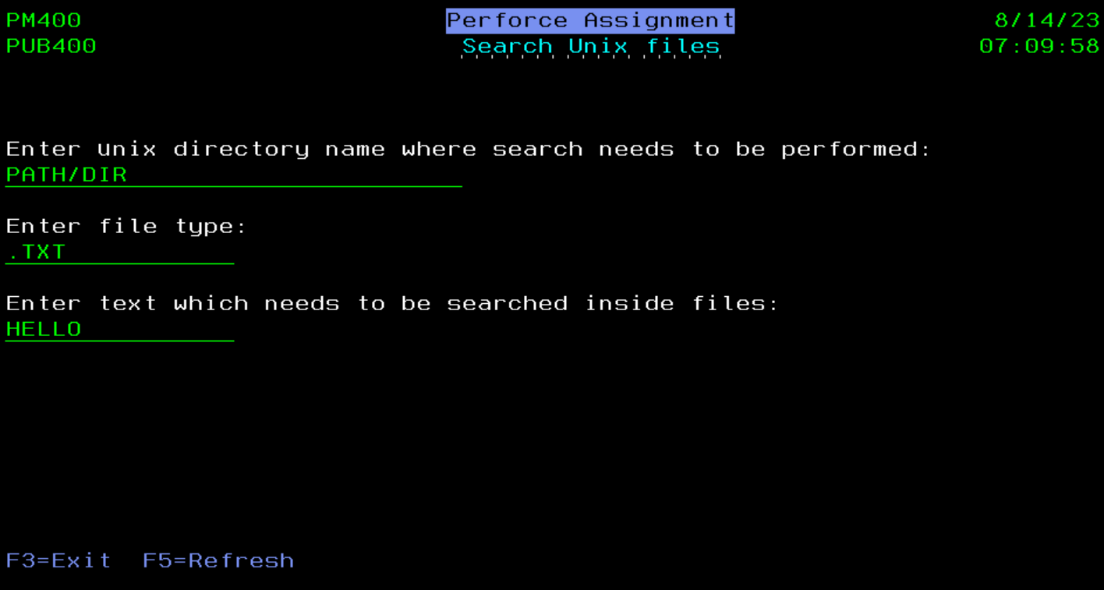

Press Enter and program will show result as below:

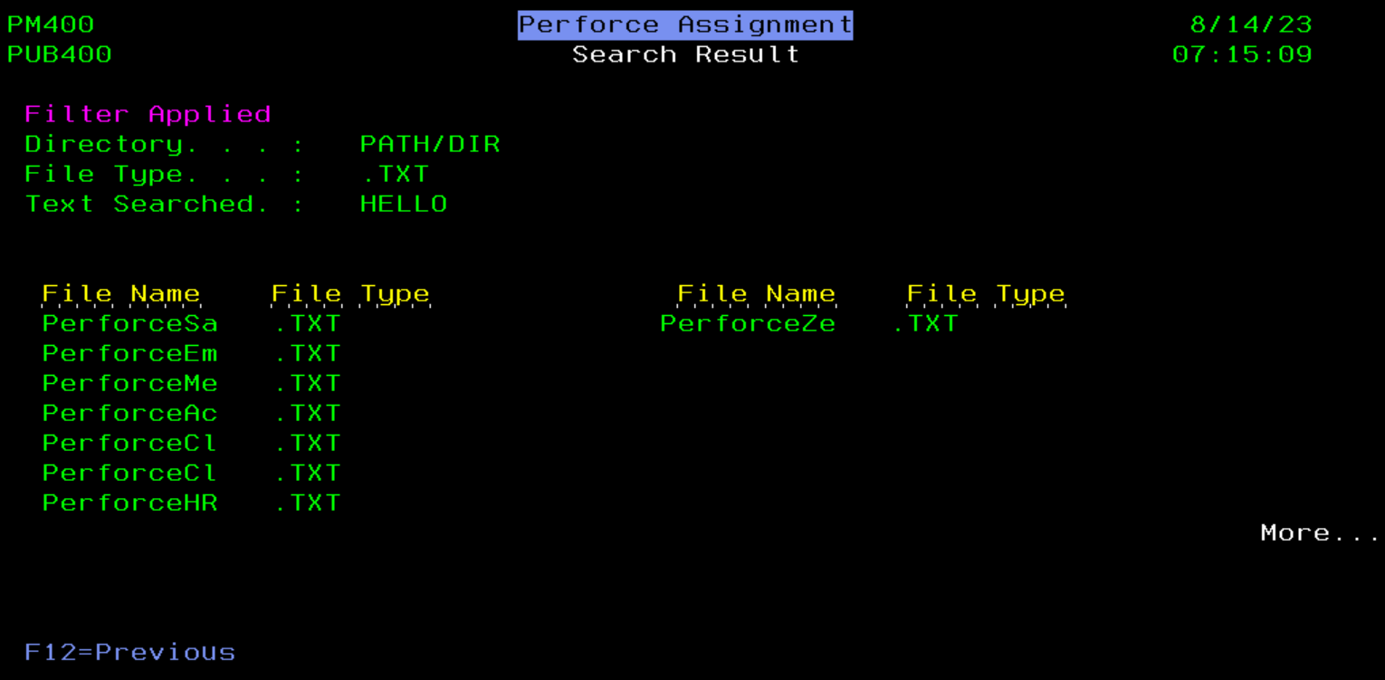

**Program Flow:**

* MainPgm1 (RPGLE) calls to C program - CPGM1.
* CPGM1 generates output to file result.txt in Path/Dir
* CPGM1 calls to GetResult (CLP) to copy data from Path/Dir/result.txt to AS400/result (*file)
* MainPgm1 reads data from AS400/result file and display on subfile screen.

**Submissions**:

Below files are submitted vai Git

* Assessment Solution Document (This document)
* C program code
* AS400 program code (CLP, RPGLE,DSPF)